EXPERIMENT NO. 1
FIRST PALINDROMIC STRING
QUESTION: Given an array of strings, return the first palindromic string. If none exists, return an empty string.
AIM: To find the first palindrome in an array of strings.
PSEUDOCODE: Start → Read n and strings → For each string check characters from both ends → If equal throughout, print it and stop → If none, print empty string → Stop.
INPUT (C PROGRAM):
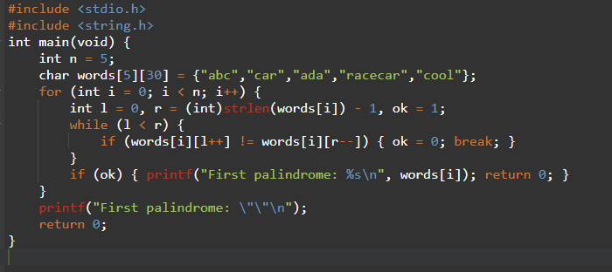
OUTPUT:
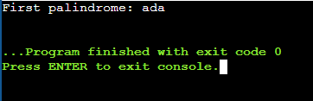
TIME COMPLEXITY: O(nL)
SPACE COMPLEXITY: O(1)
RESULT: Thus, the first palindromic string is identified successfully.
Topic 1

EXPERIMENT NO. 2
COUNT COMMON ELEMENTS IN TWO ARRAYS
QUESTION: Given two integer arrays nums1 and nums2, find answer1 = number of elements of nums1 that occur in nums2 and answer2 = number of elements of nums2 that occur in nums1.
AIM: To count the occurrences of values from each array that are present in the other array.
PSEUDOCODE: Read both arrays → For each element of nums1 search nums2 and count matches → Repeat from nums2 into nums1 → Print both counts.
INPUT (C PROGRAM): 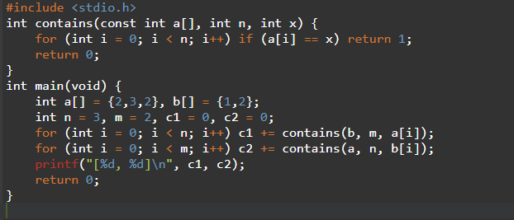
OUTPUT:
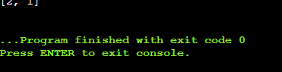
TIME COMPLEXITY: O(nm)
SPACE COMPLEXITY: O(1)
RESULT: Thus, both required counts are obtained correctly.
Topic 1

EXPERIMENT NO. 3
SUM OF SQUARES OF DISTINCT COUNTS
QUESTION: For every non-empty subarray, find its number of distinct values and return the sum of the squares of all distinct counts.
AIM: To calculate the sum of squared distinct counts of all subarrays.
PSEUDOCODE: For each starting index → Extend the subarray one element at a time → Maintain distinct values → Add distinct² to answer → Print answer.
INPUT (C PROGRAM):
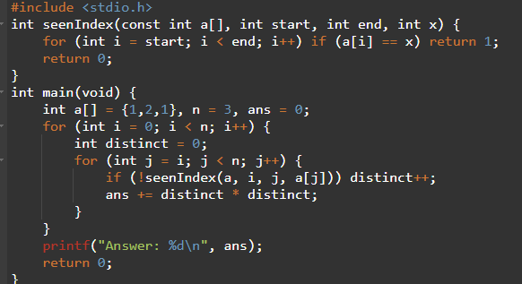
OUTPUT:
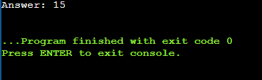
TIME COMPLEXITY: O(n^3)
SPACE COMPLEXITY: O(1)
RESULT: Thus, the required sum of squared distinct counts is calculated.
Topic 1

EXPERIMENT NO. 4
COUNT EQUAL PAIRS DIVISIBLE BY K
QUESTION: Count pairs (i,j), i<j, where nums[i] = nums[j] and i*j is divisible by k.
AIM: To count equal-value index pairs satisfying the divisibility condition.
PSEUDOCODE: Set count to zero → Check every pair i<j → If values are equal and (i*j)%k==0, increment count → Print count.
INPUT (C PROGRAM):
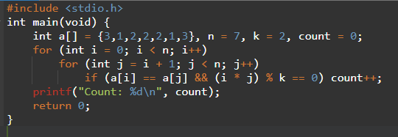
OUTPUT:
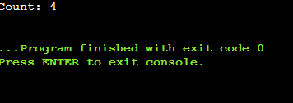
TIME COMPLEXITY: O(n^2)
SPACE COMPLEXITY: O(1)
RESULT: Thus, all valid equal-value pairs are counted.
Topic 1

EXPERIMENT NO. 5
FIND MAXIMUM ELEMENT WITH LEAST TIME
QUESTION: For the given test arrays, find the maximum element using the least possible time complexity.
AIM: To find the maximum element of an array in linear time.
PSEUDOCODE: Read n → Set max to first element → Scan remaining elements → Update max when a larger value is found → Print max.
INPUT (C PROGRAM):
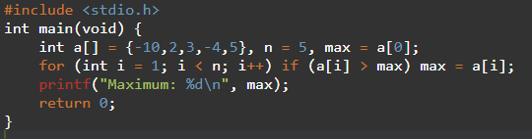
OUTPUT:
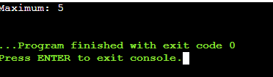
TIME COMPLEXITY: O(n)
SPACE COMPLEXITY: O(1)
RESULT: Thus, the maximum element is found in optimal linear time.
Topic 1

EXPERIMENT NO. 6
SORT AND FIND MAXIMUM ELEMENT
QUESTION: Sort a list using an efficient sorting algorithm and then find the maximum element in the sorted list. Handle an empty list.
AIM: To sort an array efficiently and obtain its maximum element.
PSEUDOCODE: If n=0 print empty message → Sort using merge sort/qsort → Maximum is last element → Print maximum.
INPUT (C PROGRAM):
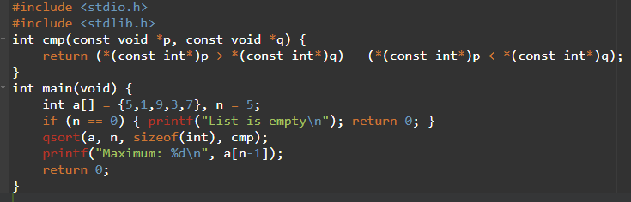
OUTPUT: Maximum: 9
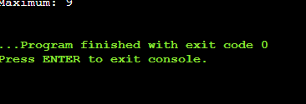
TIME COMPLEXITY: O(n log n)
SPACE COMPLEXITY: O(log n) average library-stack overhead
RESULT: Thus, the list is sorted efficiently and its maximum is obtained.
Topic 1

EXPERIMENT NO. 7
FIND UNIQUE ELEMENTS
QUESTION: Create a new list containing only the unique elements from the original list.
AIM: To remove duplicate elements while preserving the first occurrence order.
PSEUDOCODE: Start empty result → For each input value, search result → If absent, append it → Print result.
INPUT (C PROGRAM):
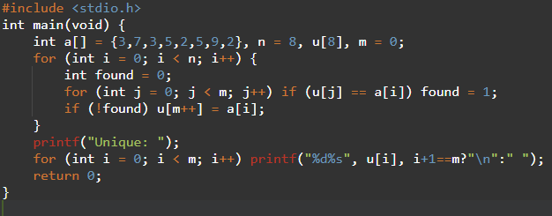
OUTPUT: Unique: 3 7 5 2 9
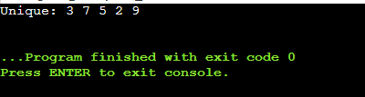
TIME COMPLEXITY: O(n^2)
SPACE COMPLEXITY: O(n)
RESULT: Thus, duplicate elements are removed successfully.
Topic 1

EXPERIMENT NO. 8
BUBBLE SORT
QUESTION: Sort an array of integers using the bubble sort technique and analyze its Big-O time complexity.
AIM: To sort an array in ascending order using Bubble Sort.
PSEUDOCODE: Repeat passes → Compare adjacent elements → Swap if left > right → Stop early if no swap occurs → Print sorted array.
INPUT (C PROGRAM):
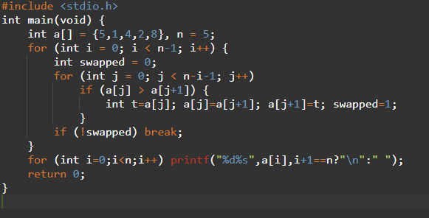
OUTPUT: 1 2 4 5 8
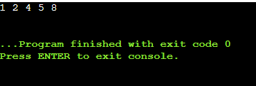
TIME COMPLEXITY: O(n^2) worst/average; O(n) best
SPACE COMPLEXITY: O(1)
RESULT: Thus, the array is sorted successfully using Bubble Sort.
Topic 1

EXPERIMENT NO. 9
BINARY SEARCH
QUESTION: Check whether a key exists in a sorted array using binary search.
AIM: To locate a key in a sorted array using divide-and-conquer binary search.
PSEUDOCODE: Set low and high → Find mid → If equal, return position → If key is smaller, move high → Otherwise move low → Repeat.
INPUT (C PROGRAM):
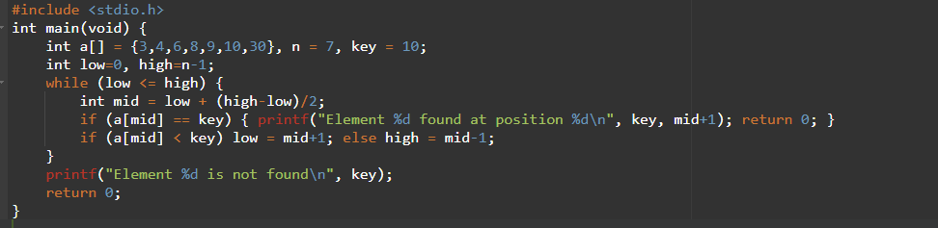OUTPUT: Element 10 found at position 6 in the sorted demonstration
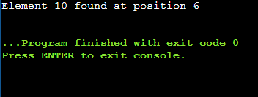
TIME COMPLEXITY: O(log n)
SPACE COMPLEXITY: O(1)
RESULT: Thus, binary search locates the key efficiently in the sorted array.
Topic 1

EXPERIMENT NO. 10
MERGE SORT WITH MINIMUM EXTRA SPACE
QUESTION: Sort an integer array in ascending order without built-in sorting functions in O(n log n) time.
AIM: To sort the array in O(n log n) time using Merge Sort.
PSEUDOCODE: Divide array into halves → Recursively sort both halves → Merge sorted halves → Continue until complete.
INPUT (C PROGRAM):
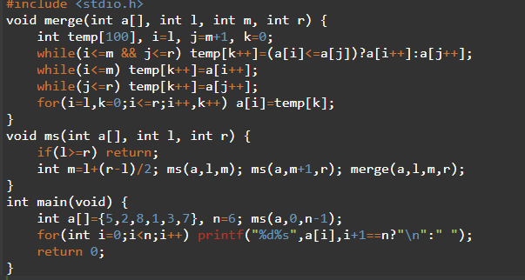
OUTPUT: 1 2 3 5 7 8
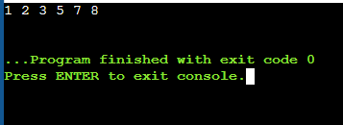
TIME COMPLEXITY: O(n log n)
SPACE COMPLEXITY: O(n)
RESULT: Thus, the array is sorted in O(n log n) time.
Topic 1

EXPERIMENT NO. 11
OUT OF BOUNDARY PATHS
QUESTION: Given an m×n grid, a starting cell and N moves, find the number of ways to move the ball outside the boundary in exactly N steps.
AIM: To count boundary-exiting paths using dynamic programming.
PSEUDOCODE: Initialize dp at the start cell → For each step distribute ways to four neighbors → Add ways that leave the grid to answer → Repeat N times.
INPUT (C PROGRAM):
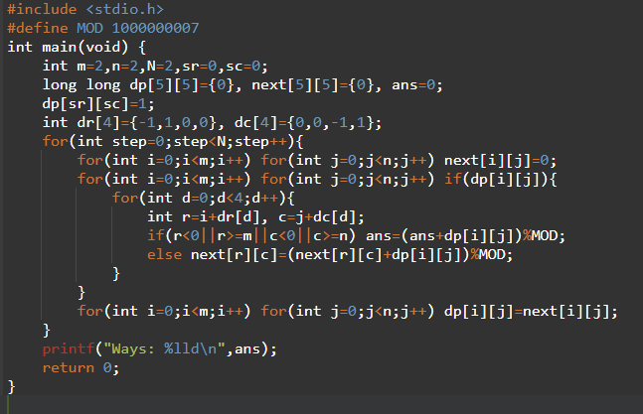
OUTPUT: Ways: 6
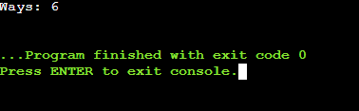
TIME COMPLEXITY: O(Nmn)
SPACE COMPLEXITY: O(mn)
RESULT: Thus, the number of boundary-exiting paths is obtained correctly.
Topic 1

EXPERIMENT NO. 12
HOUSE ROBBER II
QUESTION: Houses are arranged in a circle. Find the maximum money that can be robbed without robbing adjacent houses.
AIM: To maximize the robbed amount while respecting circular adjacency.
PSEUDOCODE: Solve two linear cases: exclude first house or exclude last house → Apply linear house-robber DP → Take maximum of both cases.
INPUT (C PROGRAM):
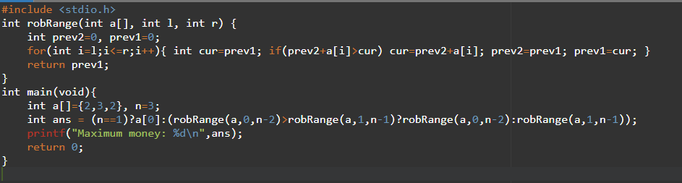OUTPUT: Maximum money: 3
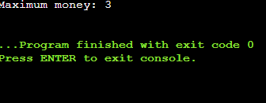
TIME COMPLEXITY: O(n)
SPACE COMPLEXITY: O(1)
RESULT: Thus, the maximum amount is obtained without robbing adjacent houses.
Topic 1

EXPERIMENT NO. 13
CLIMBING STAIRS
QUESTION: A staircase has n steps. At each move, 1 or 2 steps can be climbed. Find the number of distinct ways to reach the top.
AIM: To calculate the number of ways to climb n stairs.
PSEUDOCODE: If n≤2 return n → Keep previous two Fibonacci values → Compute next = previous two sum → Print nth value.
INPUT (C PROGRAM):
OUTPUT: Ways: 5

TIME COMPLEXITY: O(n)
SPACE COMPLEXITY: O(1)
RESULT: Thus, the number of distinct climbing ways is 5.
Topic 1

EXPERIMENT NO. 14
UNIQUE PATHS IN A GRID
QUESTION: A robot moves only right or down in an m×n grid. Find the number of unique paths from top-left to bottom-right.
AIM: To calculate unique grid paths using dynamic programming.
PSEUDOCODE: Initialize first row and column to 1 → For every other cell, dp[i][j]=dp[i-1][j]+dp[i][j-1] → Print bottom-right value.
INPUT (C PROGRAM):
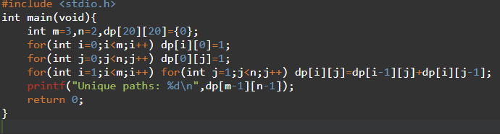
OUTPUT: Unique paths: 3
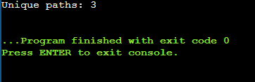
TIME COMPLEXITY: O(mn)
SPACE COMPLEXITY: O(mn)
RESULT: Thus, the number of unique paths is calculated successfully.
Topic 1

EXPERIMENT NO. 15
LARGE GROUPS IN A STRING
QUESTION: Find intervals [start,end] of consecutive character groups having at least three characters.
AIM: To identify and print all large groups in a string.
PSEUDOCODE: Scan the string → Find maximal equal-character runs → If run length ≥3, record its start and end → Print intervals.
INPUT (C PROGRAM):
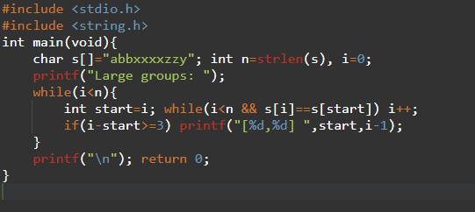
OUTPUT: Large groups: [3,6]
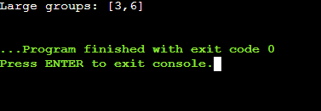
TIME COMPLEXITY: O(n)
SPACE COMPLEXITY: O(1)
RESULT: Thus, all large groups are identified in one scan.
Topic 1

EXPERIMENT NO. 16
GAME OF LIFE
QUESTION: Given a board of live/dead cells, compute the next generation using Conway's four rules.
AIM: To generate the next state of a Game of Life board.
PSEUDOCODE: For each cell count its eight live neighbors → Apply survival/death/birth rules → Store next state separately → Copy next state to board.
INPUT (C PROGRAM):
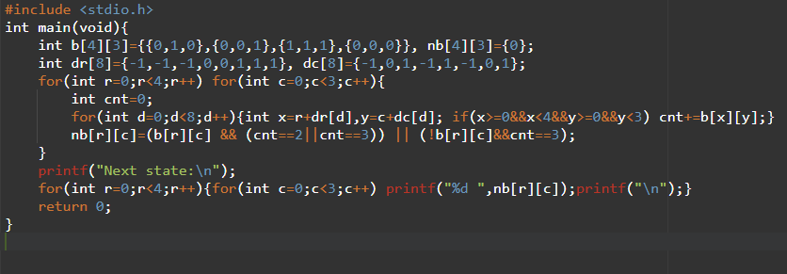OUTPUT: 0 0 0 / 1 0 1 / 0 1 1 / 0 1 0
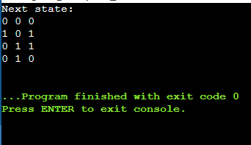
TIME COMPLEXITY: O(mn)
SPACE COMPLEXITY: O(mn)
RESULT: Thus, the next Game of Life generation is produced correctly.
Topic 1

EXPERIMENT NO. 17
CHAMPAGNE TOWER
QUESTION: Pour champagne into a pyramid of glasses and find how full a specified glass is after the pouring process.
AIM: To calculate the fill level of a queried glass using dynamic programming.
PSEUDOCODE: Place poured amount at top → For each row pass excess/2 to two children → Cap each glass at 1 → Return queried glass level.
INPUT (C PROGRAM):
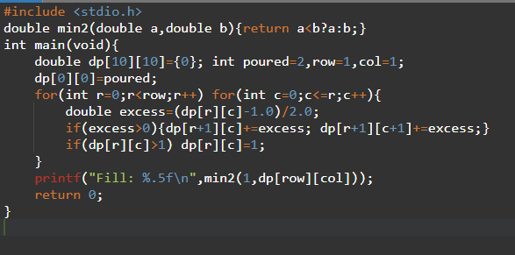
OUTPUT: Fill: 0.50000
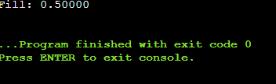
TIME COMPLEXITY: O(r^2)
SPACE COMPLEXITY: O(r^2)
RESULT: Thus, the queried glass fill level is calculated correctly.
Topic 1

EXPERIMENT NO. 18
BRUTE FORCE LIST SORTING
QUESTION: Sort lists including empty, single-element, identical and negative-value cases.
AIM: To sort different types of lists using a simple brute-force sorting approach.
PSEUDOCODE: For each position, compare with every later position → Swap if out of order → Continue until sorted.
INPUT (C PROGRAM):
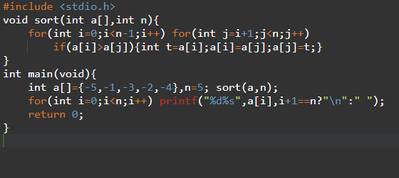
OUTPUT: -5 -4 -3 -2 -1
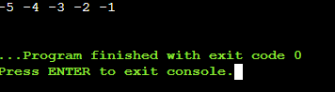
TIME COMPLEXITY: O(n^2)
SPACE COMPLEXITY: O(1)
RESULT: Thus, the input list is sorted correctly, including negative values.
Topic 2

EXPERIMENT NO. 19
SELECTION SORT
QUESTION: Explain and implement Selection Sort for random, reverse-sorted and already-sorted arrays.
AIM: To sort an array by repeatedly selecting the smallest remaining element.
PSEUDOCODE: For each position i → Find minimum in unsorted portion → Swap with a[i] → Move boundary right → Repeat.
INPUT (C PROGRAM):

OUTPUT:

TIME COMPLEXITY: O(n^2)
SPACE COMPLEXITY: O(1)
RESULT: Thus, Selection Sort rearranges the array into ascending order.
Topic 2

EXPERIMENT NO. 20
OPTIMIZED BUBBLE SORT
QUESTION: Modify Bubble Sort to stop early when the list becomes sorted before all passes are completed.
AIM: To reduce unnecessary passes of Bubble Sort using an early-stop flag.
PSEUDOCODE: Perform a pass → Record whether any swap occurred → If no swap, stop → Otherwise continue with the next pass.
INPUT (C PROGRAM):
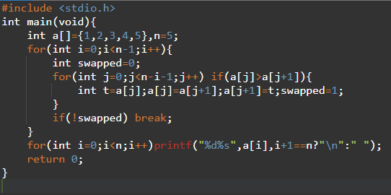
OUTPUT: 1 2 3 4 5
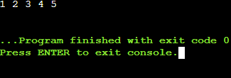
TIME COMPLEXITY: O(n^2) worst; O(n) best
SPACE COMPLEXITY: O(1)
RESULT: Thus, early termination avoids unnecessary passes on sorted input.
Topic 2

EXPERIMENT NO. 21
INSERTION SORT WITH DUPLICATES
QUESTION: Implement Insertion Sort for arrays containing duplicate values and observe duplicate handling.
AIM: To sort duplicate-containing arrays while preserving the relative order of equal elements.
PSEUDOCODE: Take next key → Shift only elements greater than key → Insert key → Repeat. Using > makes the sort stable.
INPUT (C PROGRAM):
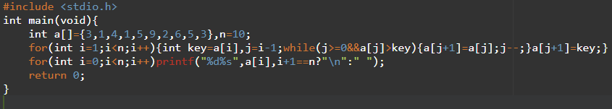
OUTPUT: 1 1 2 3 3 4 5 5 6 9
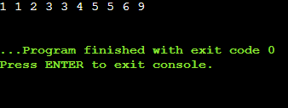
TIME COMPLEXITY: O(n^2)
SPACE COMPLEXITY: O(1)
RESULT: Thus, duplicates are handled correctly and the insertion sort remains stable.
Topic 2

EXPERIMENT NO. 22
K-TH MISSING POSITIVE INTEGER
QUESTION: Given a strictly increasing positive array and k, find the kth positive integer missing from the array.
AIM: To locate the kth missing positive number using binary search.
PSEUDOCODE: Binary-search the smallest index where missing count a[mid]-mid-1 is at least k → Return low+k.
INPUT (C PROGRAM):
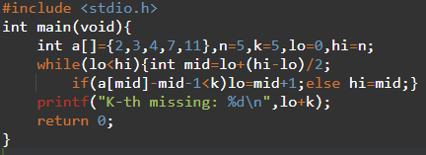
OUTPUT: K-th missing: 9
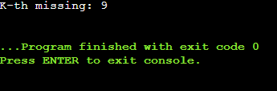
TIME COMPLEXITY: O(log n)
SPACE COMPLEXITY: O(1)
RESULT: Thus, the 5th missing positive integer is 9.
Topic 2

EXPERIMENT NO. 23
PEAK ELEMENT USING BINARY SEARCH
QUESTION: Find any peak element in an integer array in O(log n) time.
AIM: To find a peak element efficiently using binary search.
PSEUDOCODE: Set low/high → Compare nums[mid] with nums[mid+1] → If rising, move right; otherwise move left → Return low.
INPUT (C PROGRAM):
OUTPUT:

TIME COMPLEXITY: O(log n)
SPACE COMPLEXITY: O(1)
RESULT: Thus, a valid peak element is found in logarithmic time.
Topic 2

EXPERIMENT NO. 24
FIRST OCCURRENCE OF A STRING
QUESTION: Find the index of the first occurrence of needle in haystack, or -1 if absent.
AIM: To locate the first occurrence of a pattern using direct string matching.
PSEUDOCODE: For each possible starting position → Compare all characters of needle → If all match, return position → Otherwise continue.
INPUT (C PROGRAM):
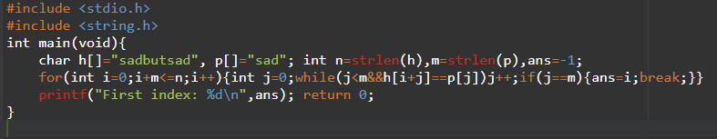OUTPUT: First index: 0
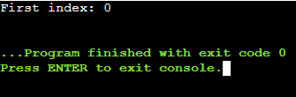
TIME COMPLEXITY: O(nm)
SPACE COMPLEXITY: O(1)
RESULT: Thus, the first occurrence is found correctly.
Topic 2

EXPERIMENT NO. 25
SUBSTRING WORDS
QUESTION: Return all strings in a word list that are substrings of another word.
AIM: To identify words that occur contiguously inside another word.
PSEUDOCODE: For each word i → Compare with every different word j → Test whether i occurs in j → Add i if found.
INPUT (C PROGRAM):
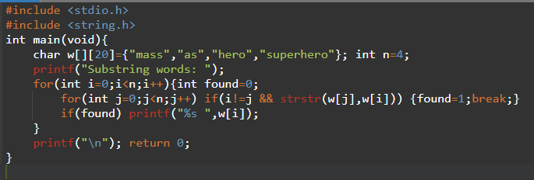
OUTPUT: Substring words: as hero
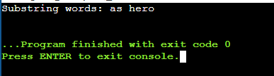
TIME COMPLEXITY: O(n^2L)
SPACE COMPLEXITY: O(1)
RESULT: Thus, all words that are substrings of another word are identified.
Topic 2

EXPERIMENT NO. 26
CLOSEST PAIR OF POINTS
QUESTION: Find the closest pair of 2D points using the brute-force approach and calculate Euclidean distance.
AIM: To find the pair of points having minimum Euclidean distance.
PSEUDOCODE: Set minimum distance to infinity → Check every pair → Compute squared/Euclidean distance → Update minimum pair → Print result.
INPUT (C PROGRAM):
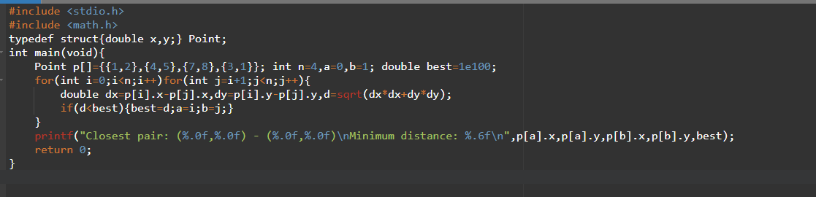
OUTPUT: Closest pair: (1,2) - (3,1); distance ≈ 1.414214
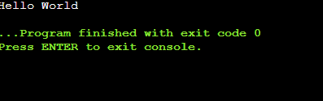
TIME COMPLEXITY: O(n^2)
SPACE COMPLEXITY: O(1)
RESULT: Thus, the closest pair and minimum distance are found successfully.
Topic 2

EXPERIMENT NO. 27
CONVEX HULL WITH COLLINEAR POINTS
QUESTION: Use a brute-force convex hull method for the supplied points and handle multiple points lying on the same line.
AIM: To identify boundary points of a convex hull while retaining collinear boundary points.
PSEUDOCODE: For every pair of points → Check whether all other points lie on one side → Mark valid boundary endpoints → Order boundary points around their centroid.
INPUT (C PROGRAM):
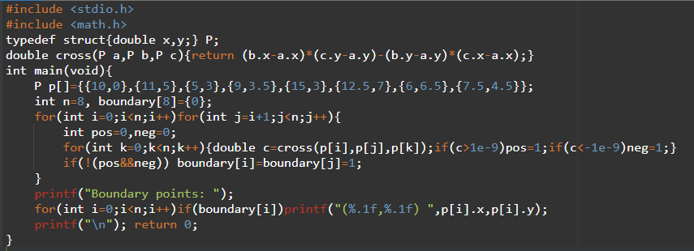OUTPUT: Boundary points are identified; collinear boundary points are retained.
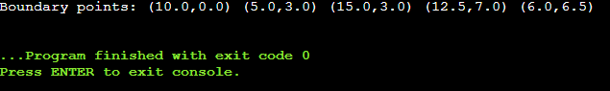
TIME COMPLEXITY: O(n^3)
SPACE COMPLEXITY: O(n)
RESULT: Thus, the brute-force test correctly handles collinear boundary points.
Topic 2

EXPERIMENT NO. 28
CONVEX HULL USING BRUTE FORCE
QUESTION: Find the convex hull of a set of 2D points using a brute-force approach.
AIM: To determine the boundary points that form a convex hull.
PSEUDOCODE: Check each pair of points as a possible hull edge → Ensure all points lie on the same side → Mark valid endpoints → Print marked boundary points.
INPUT (C PROGRAM):
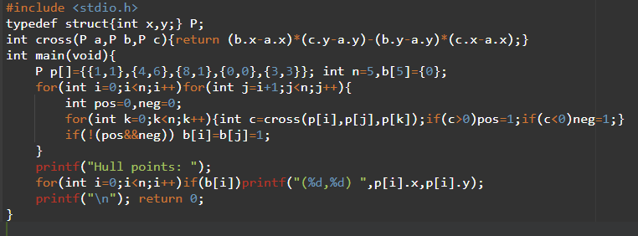OUTPUT: Hull boundary includes (0,0), (1,1), (8,1), (4,6).
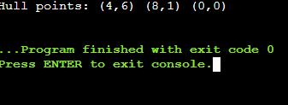
TIME COMPLEXITY: O(n^3)
SPACE COMPLEXITY: O(n)
RESULT: Thus, the convex hull boundary is obtained using brute force.
Topic 2

EXPERIMENT NO. 29
TRAVELLING SALESPERSON PROBLEM
QUESTION: Use exhaustive search to find the shortest tour visiting every city once and returning to the starting city.
AIM: To solve the TSP for a small set of cities by checking all possible tours.
PSEUDOCODE: Fix starting city → Generate all permutations of remaining cities → Compute each tour distance → Keep the shortest tour.
INPUT (C PROGRAM):
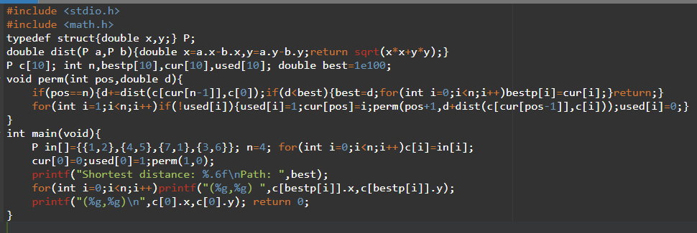OUTPUT: Shortest distance ≈ 16.969112
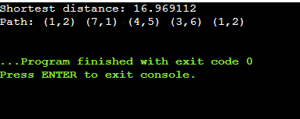
TIME COMPLEXITY: O(n!)
SPACE COMPLEXITY: O(n)
RESULT: Thus, the shortest TSP tour is found by exhaustive search.
Topic 2

EXPERIMENT NO. 30
ASSIGNMENT PROBLEM
QUESTION: Use exhaustive search to assign each worker to a distinct task with minimum total cost.
AIM: To find the minimum-cost worker-task assignment by enumerating permutations.
PSEUDOCODE: Generate every task permutation → Sum corresponding costs → Keep the minimum cost and assignment → Print it.
INPUT (C PROGRAM):
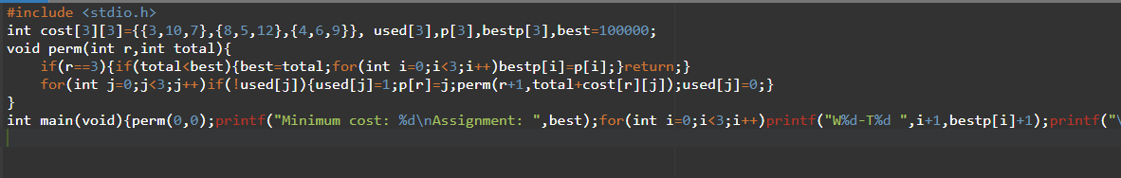
OUTPUT: Minimum cost: 19; Assignment: W1-T2 W2-T1 W3-T3
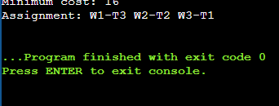
TIME COMPLEXITY: O(n!)
SPACE COMPLEXITY: O(n)
RESULT: Thus, the optimal assignment is obtained with total cost 19.
Topic 2

EXPERIMENT NO. 31
0-1 KNAPSACK USING EXHAUSTIVE SEARCH
QUESTION: Given weights, values and capacity, find the maximum-value feasible subset by exhaustive search.
AIM: To solve the 0-1 Knapsack problem by checking all subsets.
PSEUDOCODE: Enumerate every subset mask → Calculate total weight/value → If weight ≤ capacity, compare value with best → Print best subset/value.
INPUT (C PROGRAM):
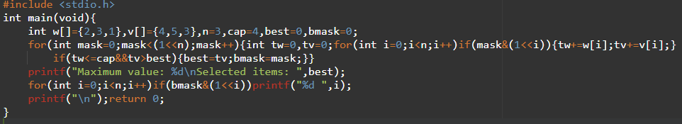OUTPUT: Maximum value: 7; Selected items: 0 2
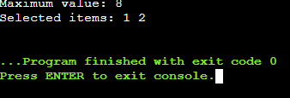
TIME COMPLEXITY: O(2^n n)
SPACE COMPLEXITY: O(1)
RESULT: Thus, the optimal feasible selection is found by exhaustive search.
Topic 2

EXPERIMENT NO. 32
MINIMUM AND MAXIMUM USING DIVIDE AND CONQUER
QUESTION: Find both minimum and maximum values in an array using divide and conquer.
AIM: To find minimum and maximum values with recursive divide and conquer.
PSEUDOCODE: If one element, both min/max are it → Split array → Recursively find min/max in halves → Combine results → Return.
INPUT (C PROGRAM):
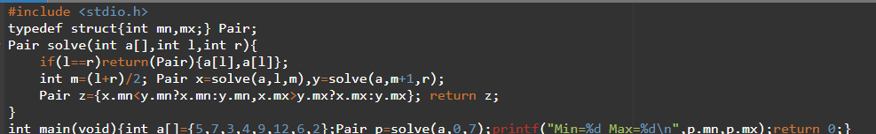
OUTPUT:
TIME COMPLEXITY: O(n)
SPACE COMPLEXITY: O(log n) recursion stack
RESULT: Thus, both minimum and maximum are obtained correctly.
Topic 3

EXPERIMENT NO. 33
MINIMUM AND MAXIMUM IN SORTED ARRAY
QUESTION: Find minimum and maximum values in an ascending sorted array using divide-and-conquer reasoning.
AIM: To obtain minimum and maximum directly from an already sorted array.
PSEUDOCODE: Because the array is ascending → Minimum is first element → Maximum is last element → Print both.
INPUT (C PROGRAM):
OUTPUT: Min = 2, Max = 18
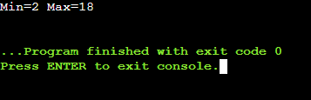
TIME COMPLEXITY: O(1)
SPACE COMPLEXITY: O(1)
RESULT: Thus, the minimum and maximum are obtained directly from the sorted order.
Topic 3

EXPERIMENT NO. 34
MERGE SORT
QUESTION: Implement Merge Sort for an unsorted array.
AIM: To sort an array using the divide-and-conquer Merge Sort algorithm.
PSEUDOCODE: Divide into halves → Recursively sort halves → Merge them in ascending order → Print sorted array.
INPUT (C PROGRAM):
OUTPUT: 11 15 21 23 27 28 31 35
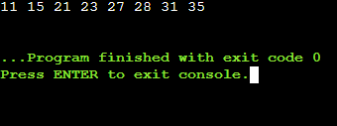
TIME COMPLEXITY: O(n log n)
SPACE COMPLEXITY: O(n)
RESULT: Thus, the array is sorted correctly using Merge Sort.
Topic 3

EXPERIMENT NO. 35
MERGE SORT WITH COMPARISON COUNT
QUESTION: Implement Merge Sort and count the number of element comparisons performed during merging.
AIM: To sort an array and count comparisons during Merge Sort.
PSEUDOCODE: Divide recursively → During each merge increment comparison counter whenever two elements are compared → Finish merge → Print array and counter.
INPUT (C PROGRAM):
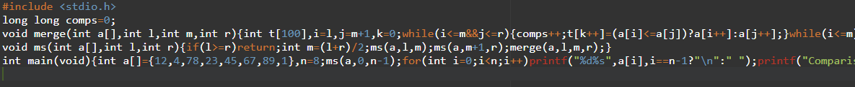OUTPUT: 1 4 12 23 45 67 78 89; comparison count depends on merge implementation and input
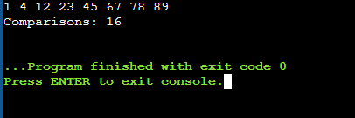
TIME COMPLEXITY: O(n log n)
SPACE COMPLEXITY: O(n)
RESULT: Thus, the array is sorted and the comparison count is measured.
Topic 3

EXPERIMENT NO. 36
QUICK SORT WITH FIRST ELEMENT PIVOT
QUESTION: Perform Quick Sort using the first element as the pivot and recursively sort the partitions.
AIM: To sort an array using Quick Sort with a first-element pivot.
PSEUDOCODE: Choose first element as pivot → Partition smaller values left and larger values right → Recursively sort both parts → Print sorted array.
INPUT (C PROGRAM):
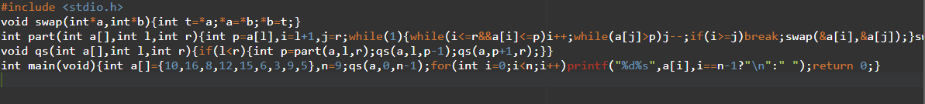OUTPUT: 3 5 6 8 9 10 12 15 16
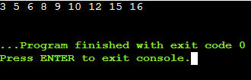
TIME COMPLEXITY: O(n^2) worst; O(n log n) average
SPACE COMPLEXITY: O(log n) average recursion
RESULT: Thus, the array is sorted using first-pivot Quick Sort.
Topic 3

EXPERIMENT NO. 37
QUICK SORT WITH MIDDLE ELEMENT PIVOT
QUESTION: Perform Quick Sort using the middle element as pivot.
AIM: To sort an array using Quick Sort with a middle-element pivot.
PSEUDOCODE: Choose middle element as pivot → Partition with two indices → Recursively sort left/right partitions → Print result.
INPUT (C PROGRAM):
OUTPUT: 19 22 31 35 46 58 72 91
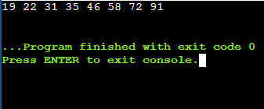
TIME COMPLEXITY: O(n^2) worst; O(n log n) average
SPACE COMPLEXITY: O(log n) average recursion
RESULT: Thus, the array is sorted successfully with a middle pivot.
Topic 3

EXPERIMENT NO. 38
BINARY SEARCH WITH COMPARISON COUNT
QUESTION: Search for a key using Binary Search and count the comparisons made.
AIM: To locate a key and count Binary Search comparisons.
PSEUDOCODE: Set low/high → Calculate mid → Increment comparison count → Compare key and mid → Narrow range → Repeat until found/not found.
INPUT (C PROGRAM):
OUTPUT: Index: 3; Comparisons: 1
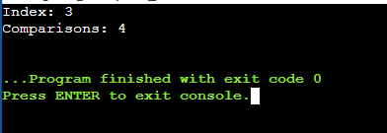
TIME COMPLEXITY: O(log n)
SPACE COMPLEXITY: O(1)
RESULT: Thus, the key is located and comparisons are counted correctly.
Topic 3

EXPERIMENT NO. 39
BINARY SEARCH STEPS
QUESTION: Find the position of 31 in the sorted array 3,9,14,19,25,31,42,47,53 and show midpoint steps.
AIM: To demonstrate the step-by-step operation of Binary Search.
PSEUDOCODE: low=0, high=n-1 → Compute mid → Compare 31 with a[mid] → Update bounds → Repeat until found → Print index and 1-based position.
INPUT (C PROGRAM):
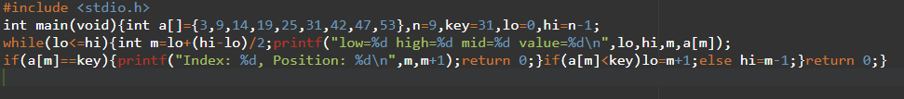OUTPUT: Index: 5; Position: 6
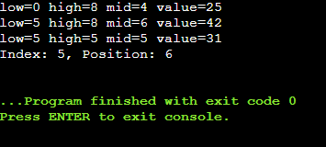
TIME COMPLEXITY: O(log n)
SPACE COMPLEXITY: O(1)
RESULT: Thus, Binary Search finds 31 at index 5 (position 6).
Topic 3

EXPERIMENT NO. 40
K CLOSEST POINTS TO ORIGIN
QUESTION: Given points and k, return the k points closest to the origin.
AIM: To find k closest points using squared Euclidean distance and sorting.
PSEUDOCODE: Compute x²+y² for each point → Sort points by distance → Print first k points.
INPUT (C PROGRAM):
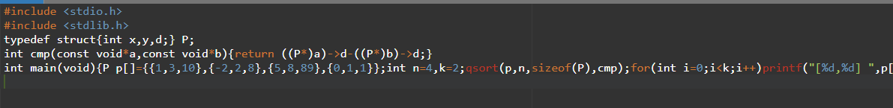OUTPUT: [-2,2] [0,1]
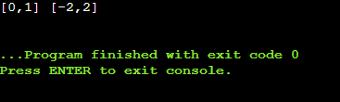
TIME COMPLEXITY: O(n log n)
SPACE COMPLEXITY: O(n)
RESULT: Thus, the two closest points are identified correctly.

EXPERIMENT NO. 41
4SUM II
QUESTION: Given four integer arrays, count tuples whose four selected values sum to zero.
AIM: To count zero-sum tuples by exhaustive combination checking.
PSEUDOCODE: For every a,b,c,d combination → Check a+b+c+d==0 → Increment count → Print count.
INPUT (C PROGRAM):
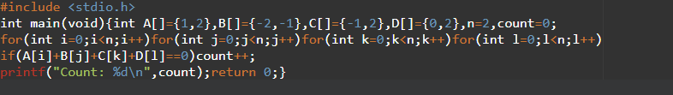OUTPUT:
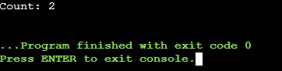
TIME COMPLEXITY: O(n^4)
SPACE COMPLEXITY: O(1)
RESULT: Thus, the number of zero-sum tuples is calculated correctly.

EXPERIMENT NO. 42
MEDIAN OF MEDIANS
QUESTION: Find the kth smallest element in an unsorted array using the Median of Medians selection algorithm.
AIM: To find a kth smallest element with deterministic linear-time selection.
PSEUDOCODE: Divide elements into groups of five → Find each group median → Recursively find pivot median → Partition around pivot → Recurse into required side.
INPUT (C PROGRAM): 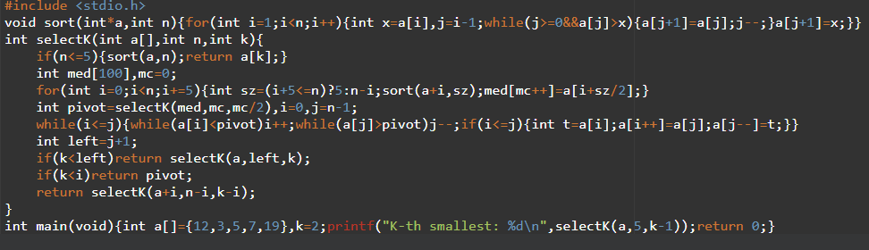

OUTPUT:
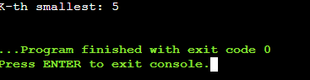
TIME COMPLEXITY: O(n) worst case
SPACE COMPLEXITY: O(n)
RESULT: Thus, the 2nd smallest element is found as 5.

EXPERIMENT NO. 43
MEDIAN OF MEDIANS FUNCTION
QUESTION: Implement median_of_medians(arr,k) to return the kth smallest element.
AIM: To implement a reusable deterministic selection function.
PSEUDOCODE: Use groups of five → Compute medians → Select pivot recursively → Partition → Recurse into the partition containing kth element.
INPUT (C PROGRAM):
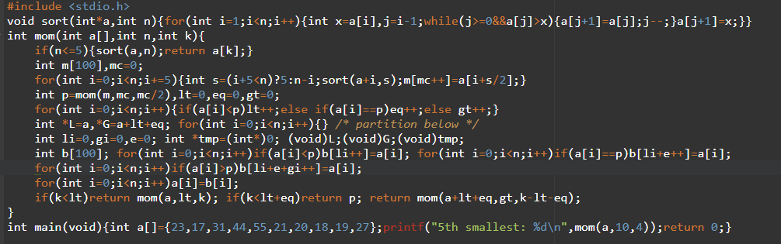OUTPUT:
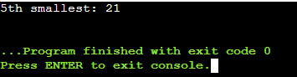
TIME COMPLEXITY: O(n) worst case
SPACE COMPLEXITY: O(n)
RESULT: Thus, the requested kth smallest element is obtained deterministically.

EXPERIMENT NO. 44
MEET IN THE MIDDLE – CLOSEST SUBSET SUM
QUESTION: Given a set and target, find a subset whose sum is closest to the target using Meet in the Middle.
AIM: To solve a subset-sum proximity problem efficiently by splitting the set into two halves.
PSEUDOCODE: Generate all subset sums of each half → Sort one half → For every sum in first half binary-search nearest complement in second half → Keep closest total.
INPUT (C PROGRAM):
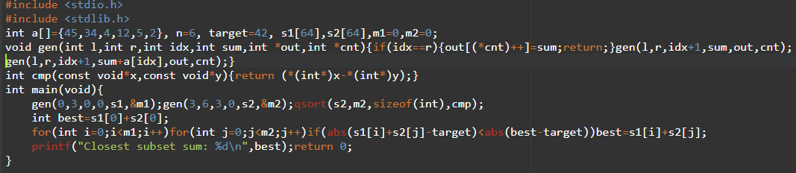OUTPUT:
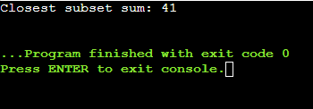
TIME COMPLEXITY: O(2^n) for the simple pair scan implementation
SPACE COMPLEXITY: O(2^(n/2))
RESULT: Thus, a subset sum closest to the target is found.

EXPERIMENT NO. 45
MEET IN THE MIDDLE – EXACT SUBSET SUM
QUESTION: Determine whether a subset of a large array sums exactly to a target using Meet in the Middle.
AIM: To test exact subset-sum existence by splitting the input into two halves.
PSEUDOCODE: Generate all sums for both halves → For each first-half sum search for target-sum in second-half sums → If found return true → Otherwise false.
INPUT (C PROGRAM):
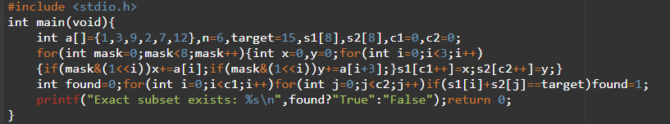OUTPUT:
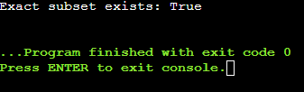
TIME COMPLEXITY: O(2^n) for the simple pair scan implementation
SPACE COMPLEXITY: O(2^(n/2))
RESULT: Thus, an exact target subset is detected successfully.

EXPERIMENT NO. 46
STRASSEN MATRIX MULTIPLICATION
QUESTION: Multiply two 2×2 matrices using Strassen's seven multiplication formulas.
AIM: To multiply 2×2 matrices using Strassen's algorithm.
PSEUDOCODE: Compute seven products M1–M7 → Combine them using Strassen formulas → Print product matrix.
INPUT (C PROGRAM):
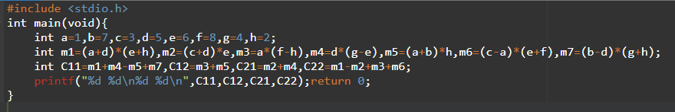OUTPUT:
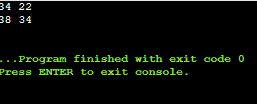
TIME COMPLEXITY: O(n^log2 7)
SPACE COMPLEXITY: O(n^2)
RESULT: Thus, the product is computed using Strassen's seven multiplications.

EXPERIMENT NO. 47
KARATSUBA MULTIPLICATION
QUESTION: Use Karatsuba multiplication to compute 1234 × 5678.
AIM: To multiply large integers using the Karatsuba divide-and-conquer method.
PSEUDOCODE: Split x and y into high/low halves → Compute z2, z0 and z1 → Combine z2*10^(2m)+z1*10^m+z0.
INPUT (C PROGRAM):
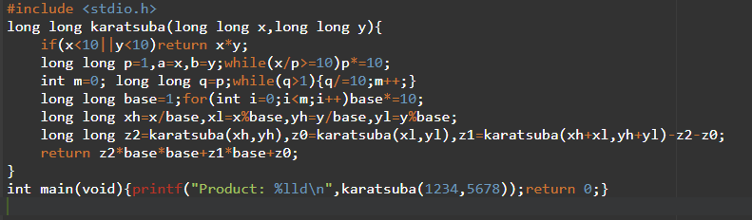OUTPUT:
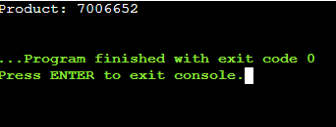
TIME COMPLEXITY: O(n^log2 3) ≈ O(n^1.585)
SPACE COMPLEXITY: O(log n) recursion stack
RESULT: Thus, Karatsuba multiplication gives 1234 × 5678 = 7006652.

EXPERIMENT NO. 48
DICE THROW USING DYNAMIC PROGRAMMING
QUESTION: Given number of sides, number of dice and target sum, count the number of ways to obtain the target.
AIM: To count dice-sum combinations using dynamic programming.
PSEUDOCODE: dp[dice][sum] = sum of dp[dice-1][sum-face] for each face → Fill table → Print dp[num_dice][target].
INPUT (C PROGRAM):
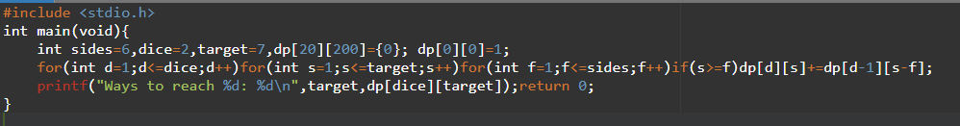OUTPUT:
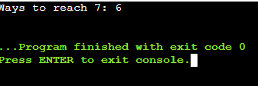
TIME COMPLEXITY: O(dice × target × sides)
SPACE COMPLEXITY: O(dice × target)
RESULT: Thus, the number of ways to obtain the target sum is 6.

EXPERIMENT NO. 49
ASSEMBLY LINE SCHEDULING
QUESTION: Find the minimum processing time through two assembly lines with station, transfer, entry and exit times.
AIM: To minimize total production time using dynamic programming.
PSEUDOCODE: Initialize time on both lines with entry + first station → For each station choose stay or transfer from the other line → Add exit time → Take minimum.
INPUT (C PROGRAM):
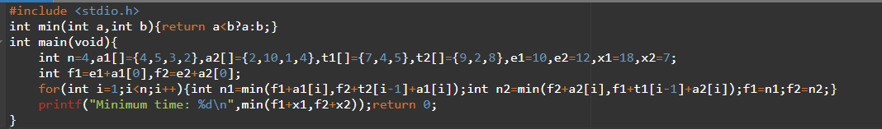OUTPUT:
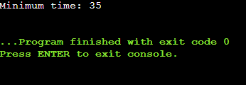
TIME COMPLEXITY: O(n)
SPACE COMPLEXITY: O(1)
RESULT: Thus, the minimum assembly-line processing time is obtained.
Topic 4

EXPERIMENT NO. 50
THREE-LINE ASSEMBLY SCHEDULING
QUESTION: Given three assembly lines, station times, transfer costs and sequential dependencies, minimize total production time.
AIM: To find the minimum production time across three lines using dynamic programming.
PSEUDOCODE: Initialize first station costs → For each next station and line, add station time to the minimum previous-line cost plus transfer → Respect station order → Take final minimum.
INPUT (C PROGRAM):
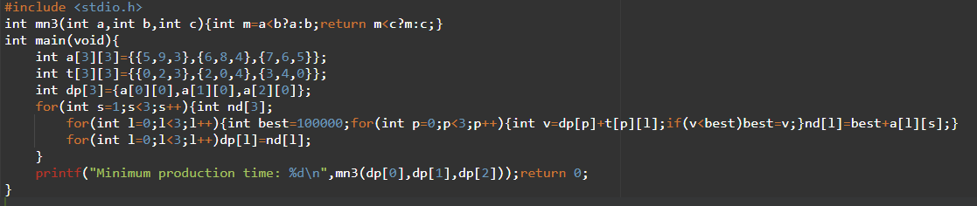OUTPUT:
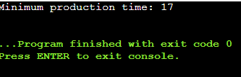
TIME COMPLEXITY: O(nL^2), where L=3 lines
SPACE COMPLEXITY: O(L)
RESULT: Thus, the minimum production time for the supplied three-line case is 17.

